
HIGHAM FERRERS TOWN BOWLS CLUB
2024-2025

Membership Type:- Full £65 Full (1st year ) £35 Social £15 Junior £15

Payment methods:- Card Cash Cheque.

(please circle membership type and payment method)

Season: 1st April to 31st March

Name:__________________________________________________________

Address:________________________________________________________

________________________________________________________

Post Code: ___________________ Email:____________________________

Tel. No: Mobile:__________________________ Home:__________________

By completing this form and signing below:-

I give consent to the use of photography or video by the Club in the coaching or promotion of bowls.
I confirm, that to the best of my knowledge, all information on this form is accurate and I undertake to advise the Club of any changes.
Data Protection. I understand and agree that the Club will use the information on this form and other information about me to register with the appropriate leagues and that in some cases this may require the Club to disclose that information to Bowls Northamptonshire and/or Bowls England. This data will also be used for regular Club communications. Data will not be passed on to third parties without consent and will be held confidentially.
I have read the Club’s Privacy Notice.

Emergency Contact Name:__________________________________________
Emergency Contact No:____________________________________________
Signature of member ________________________________Date__________

(Club bank details:- Lloyds acc.no 86982668 sort code 30-99-50)
HIGHAM FERRERS TOWN BOWLS CLUB PRIVACY NOTICE
We are committed to respecting your privacy. This notice is to explain how we may use personal information we collect before, during and after your membership with us. This notice explains how we comply with the law on data protection, what your rights are and for the purposes of data protection we will be the controller of any of your personal information.
We have not appointed a Data Protection Officer to oversee our compliance with data protection laws, as we are not required to do so, but The Chief Executive of Bowls England has overall responsibility for data protection compliance in our organisation.

1. PERSONAL INFORMATION WE MAY COLLECT FROM YOU
When you sign up with us, you may provide us with or we may obtain personal information about you, such as information regarding your:
- personal contact details that allow us to contact you directly such as name, title, email addresses and telephone numbers;
- membership details including start and end date;
- records of your interactions with us such as telephone conversations, emails and other correspondence and your instructions to us;
- any credit/debit card and other payment details you provide so that we can receive payments from you and details of the financial transactions with you;
- use of and movements through our Facebook page and Whats App Group.
- images in video and/or photographic form and voice recordings;
Players/Participants
If you are a player/participant who has registered his/her interest in participating in the sport competitively, you may also provide us with or we may obtain the following additional personal information from you:
- details of emergency contacts;
- records and assessment of any player rankings, gradings or ratings, competition results, details regarding matches and games attended and performance.
- any disciplinary and grievance information; and
- any details required for the purposes of awarding funding or grants
- it is necessary for the establishment, exercise or defence of legal claims;

2. WHERE WE COLLECT YOUR INFORMATION
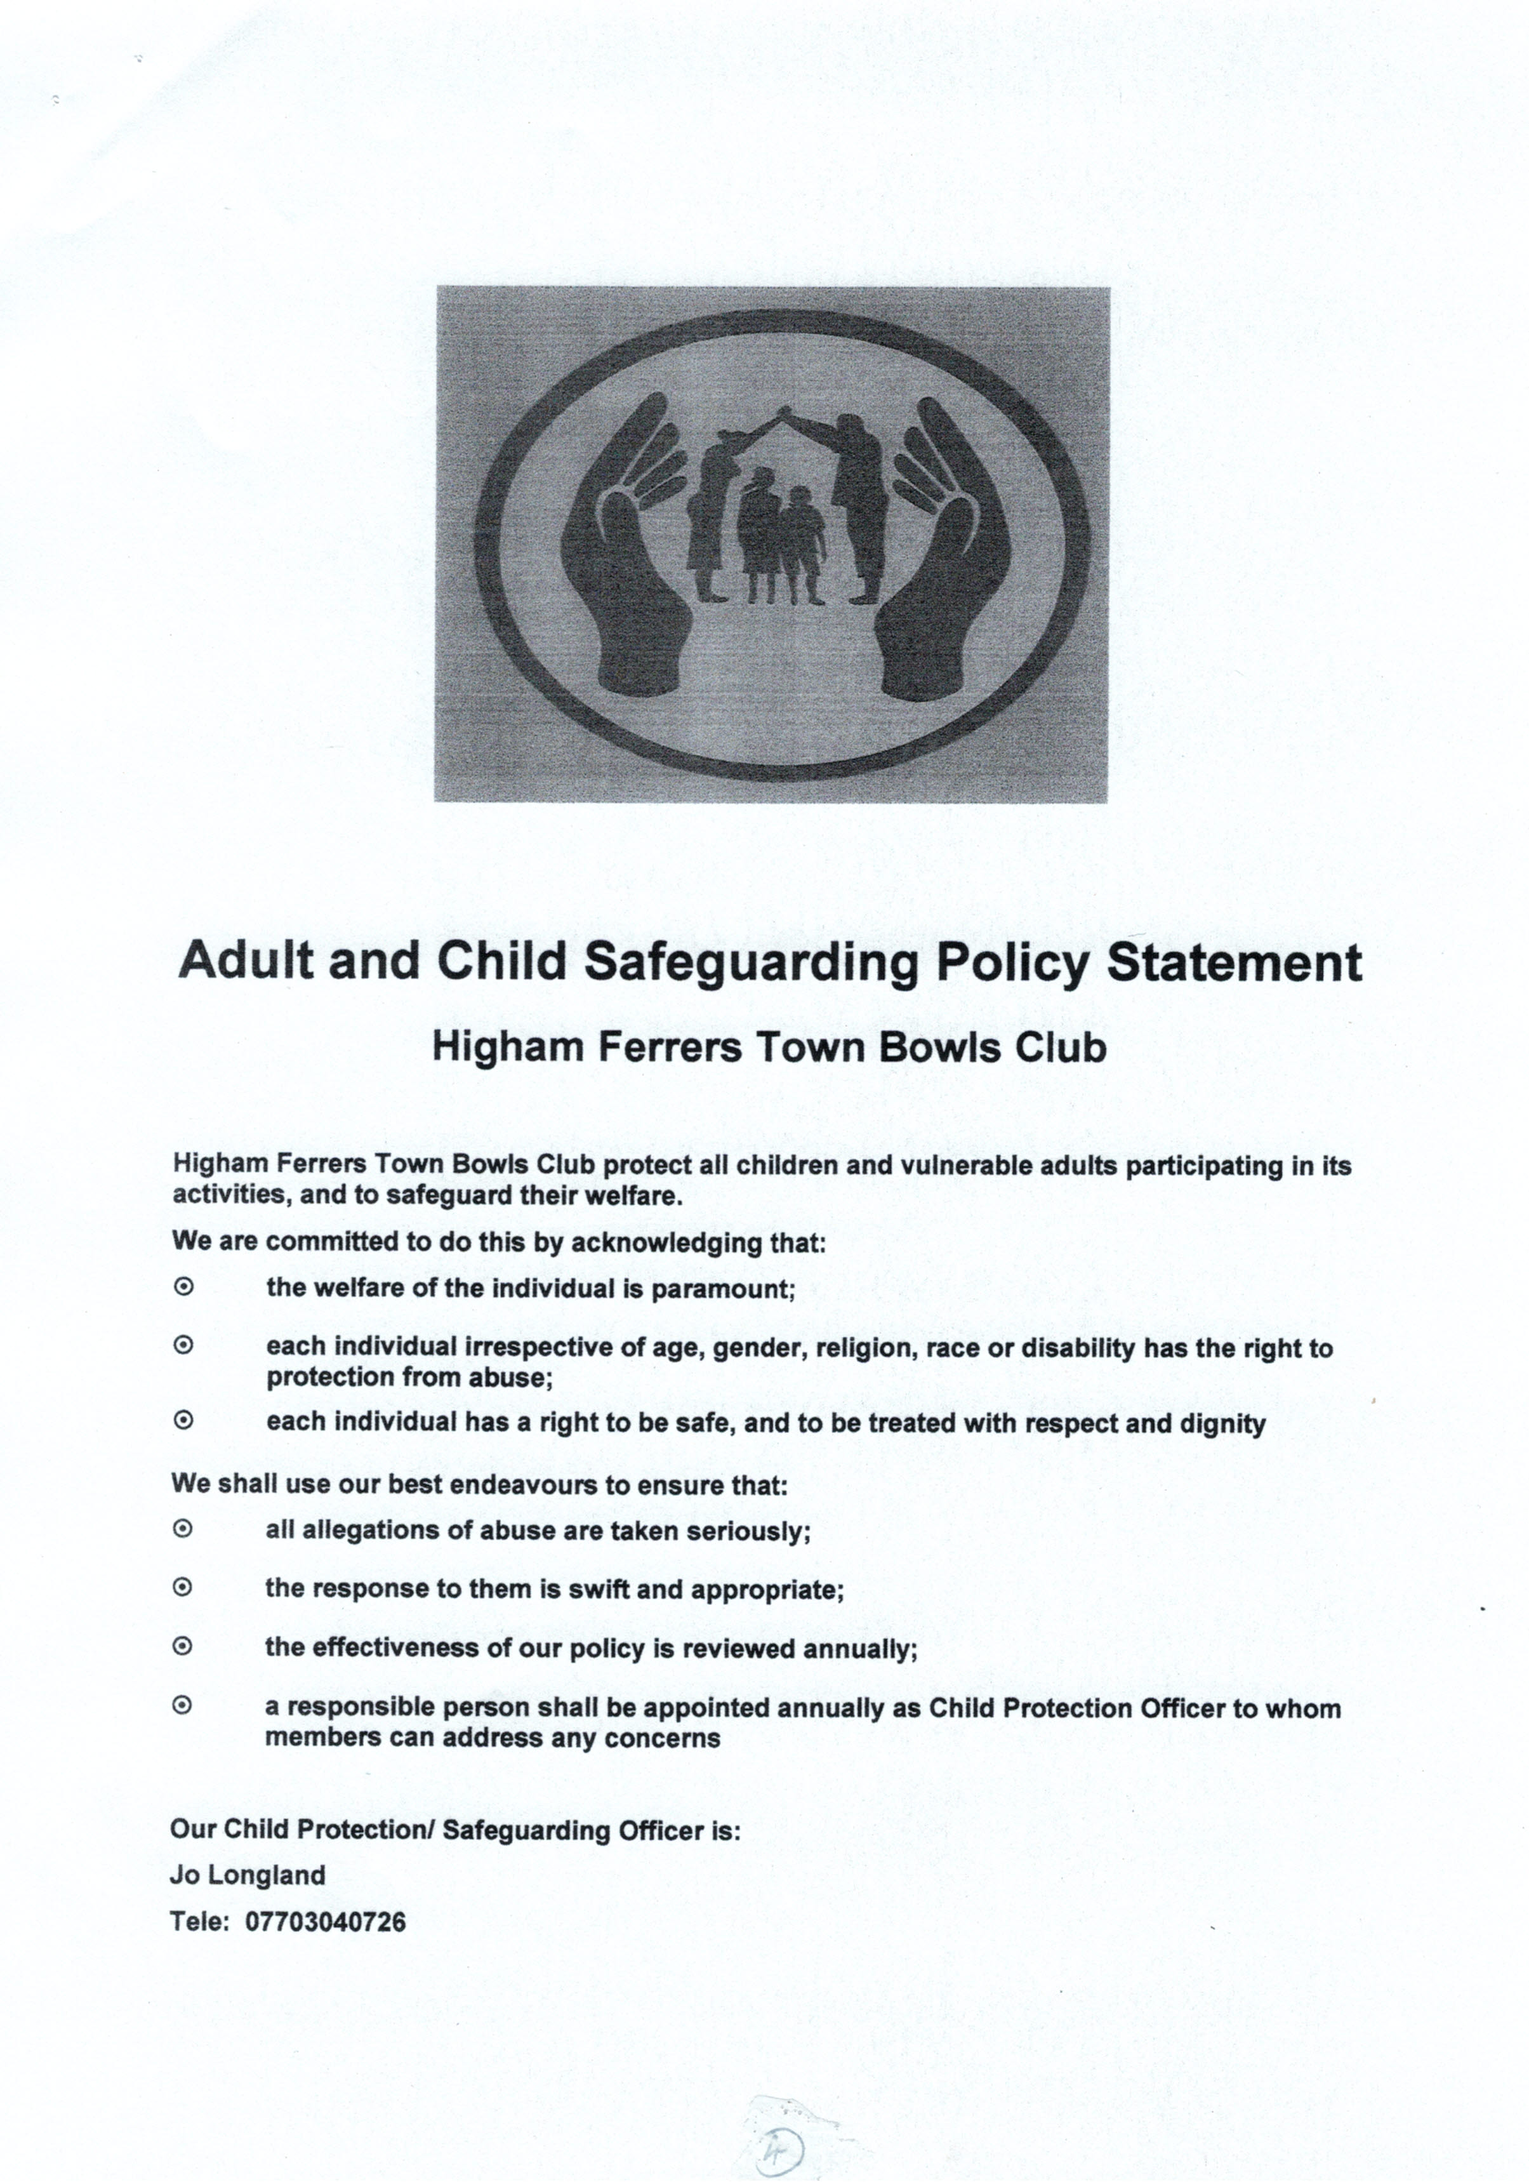
We typically collect personal information about our members when you complete a membership form at the beginning of the season. When you make a query and/or complaint or when you correspond with us by phone, e-mail or in some other way.

